Practical Exam (60 Marks)
Instructions
You have been provided with a folder containing project files in Brightspace.
Your task is to place this project under source control using Git and synchronize your work with GitHub.
The final repository on GitHub must demonstrate all required activities and contain the expected commit history.
Scenario
You have just joined a project team and received project files from another developer.
Task 1 - Create Repository (10 Marks)
- Create a new local Git repository.
- Add the project files provided.
- Create a new GitHub repository.
- Connect the local repository to GitHub.
- Upload the project to GitHub.

Task 2 - Branch Development (15 Marks)
- Create a branch named: feature/about-page
- Switch to the newly created branch.
- Modify the about.html file to include your favourite part of college so far.
- Modify the contact.html file to include your name and email address.
- Record your changes.
- Synchronize your branch with GitHub.

Task 3 - Main Branch Changes (10 Marks)
- Switch back to the main branch.
- Modify the about.html file to include the tag-line “When you know you go to NBCC”.
- Record the changes.
- Synchronize the updated main branch with GitHub.

Task 4 - Incorporate Main Changes (10 Marks)
- Return to the feature branch.
- Bring the latest main branch changes into the feature branch.
- Resolve any conflicts that occur (keep both changes on separate lines).
- Make a change to index.html (your choice!)
- Synchronize the updated feature branch with GitHub.

Task 5 - Complete Integration (15 Marks)
- Switch to the main branch.
- Integrate the completed feature branch.
- Verify all expected content exists.
- Synchronize the finished project with GitHub and submit the link to Brightspace.
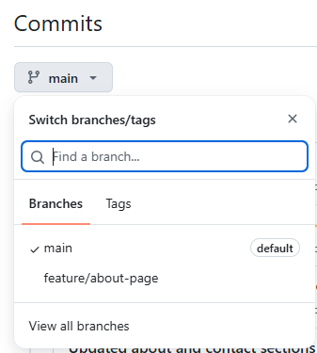
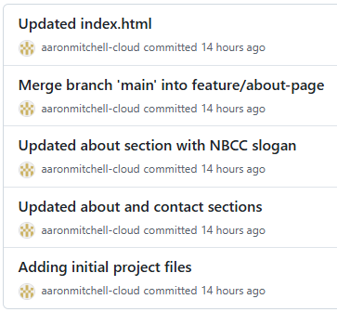
Rubric
Skill | Marks
Repository created correctly | 5
Initial commit completed | 5
Remote repository configured | 5
Initial push successful | 5
Feature branch created and used | 5
Feature changes committed | 5
Feature branch pushed | 5
Main branch changes committed | 5
Conflict resolved correctly | 10
Feature successfully merged into main | 5
Final push completed | 5

